**Networking and Distributed Systems**

**Chapter 1:**

-Telecommunication means communication at a distance.

-The word data refers to information presented in whatever form is agreed upon by the parties creating and using the data.

-Data communications are the exchange of data between two devices via some form of transmission medium such as wire cable.

-Data communication: The effectiveness of a data communication system depends on three fundamental characteristics:

1) Delivery: The system must deliver data to the correct destination.

2) Accuracy: The system must deliver data correctly.

3) The system must deliver data in a timely manner.

-Networks: is a set of devices (often referred to as nodes) connected by media links.



-Performance: can be measured in many ways, including transit time and response time.

-Performance depends on:

-Number of users

-Type of transmission medium

-Hardware

-Software

-Reliability of network includes accuracy of delivery.

-Reliability of network is measured by:

-Frequency of failure

-Recovery time of a network after failure

-Catastrophe

-Network security issues include protecting data from:

-Unauthorized access

-Viruses

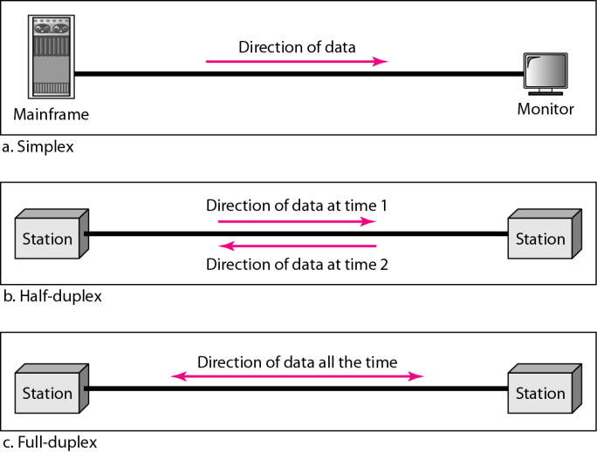

-A network is a set of devices ( often referred to as nodes) connected by communication links. A node can be a computer, printer, or any other device capable of sending and/or receiving data generated by other nodes on the network.

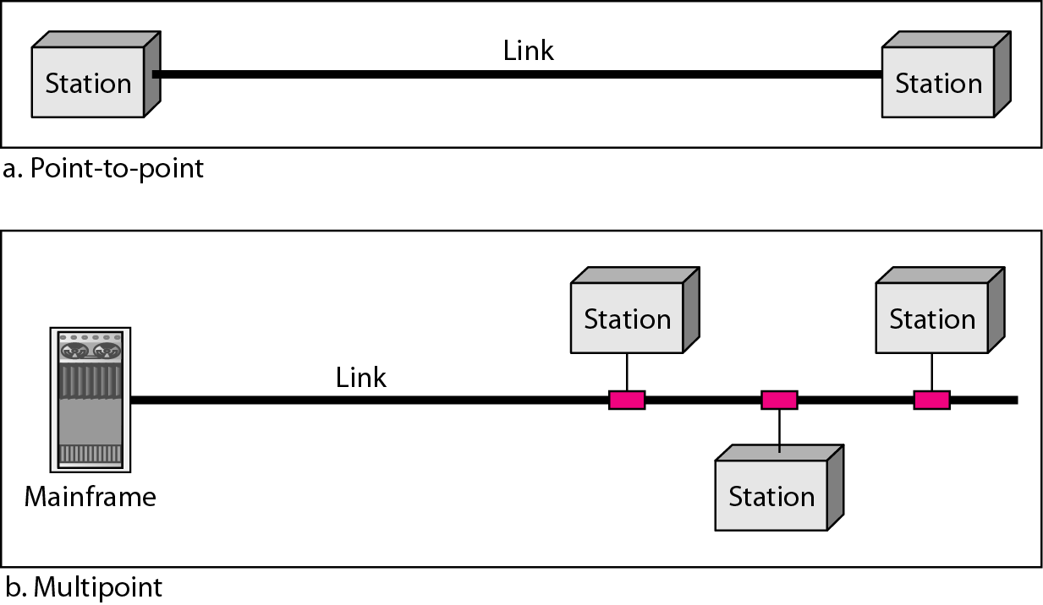

**Mesh Topology:**

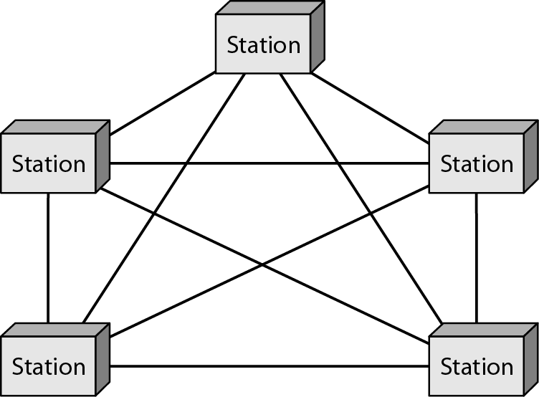

Advantages:

-Use of dedicated links guarantees that each link carry its own data load.

-Robust, if one link becomes unusable, it does not incapacitate the entire system.

-Privacy or security, only intended recipient see the message traveling along the dedicated link.

Disadvantages:

-Related to the amount of cabling and number of I/O ports required.

-Installation and reconfiguration are difficult.

-Hardware required is expensive.

**Star Topology:**

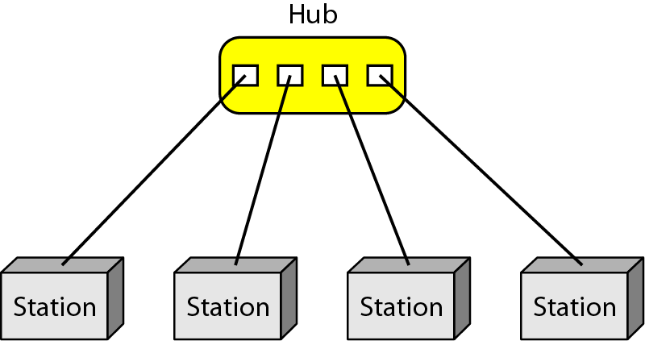

Advantages:

-Robust, if one link fails, only that link is affected.

-Easy fault identification and fault isolation.

Disadvantages:

-Cabling amount.

**Bus Topology:**

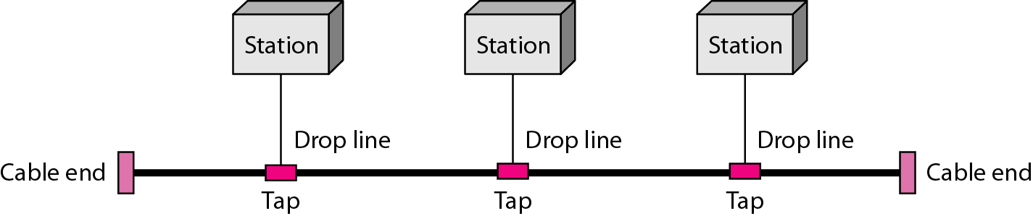

Advantages:

-Installation is easy.

Disadvantages:

-Reconfiguration and fault isolation are difficult.

**Ring Topology:**

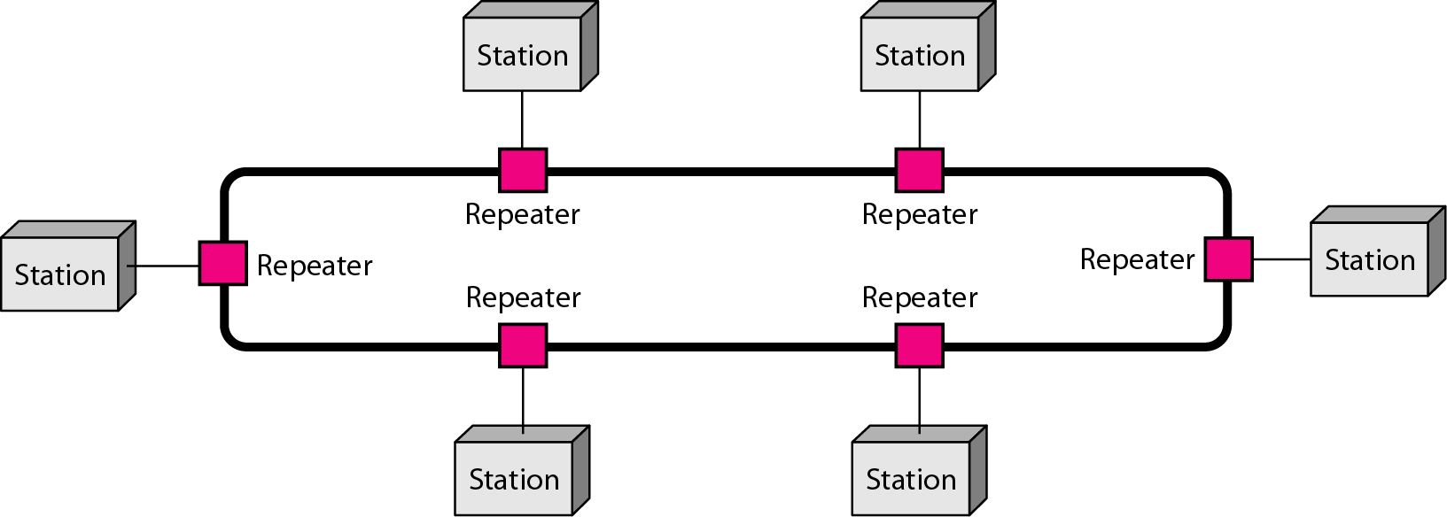

Advantages:

-Installation and reconfiguration are easy.

-Fault isolation is simplified. (Alarm alert for signal lack)

-Dual Ring or switches are used to overcome ring break.

All topologies can be implemented alone or as hybrid systems containing multiple types.



-The Internet is a communication system.

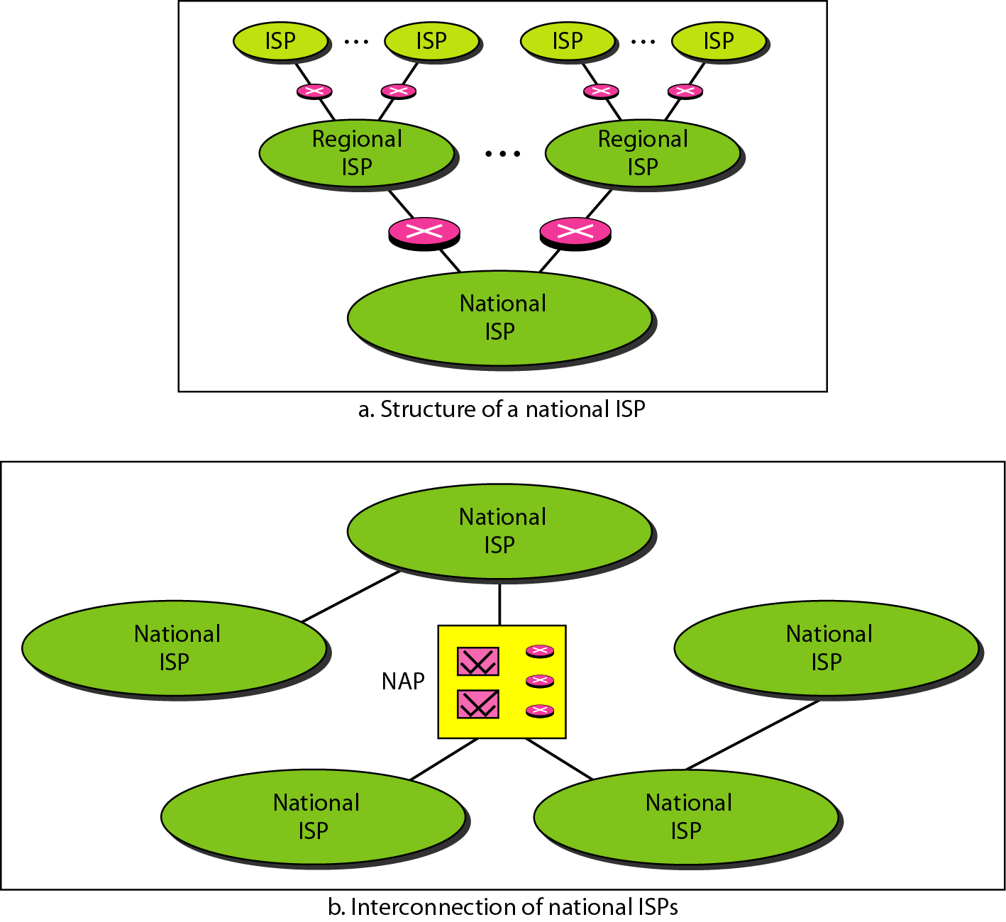

-Protocol is synonymous with rule.

-Standards are agreed upon rules.

**Chapter 2:**

-International Standards Organization (ISO) is a multinational body dedicated to worldwide agreement on international standards. An ISO standard that covers all aspects of network communications is the Open Systems Interconnection (OSI) model. (Late 1970's)

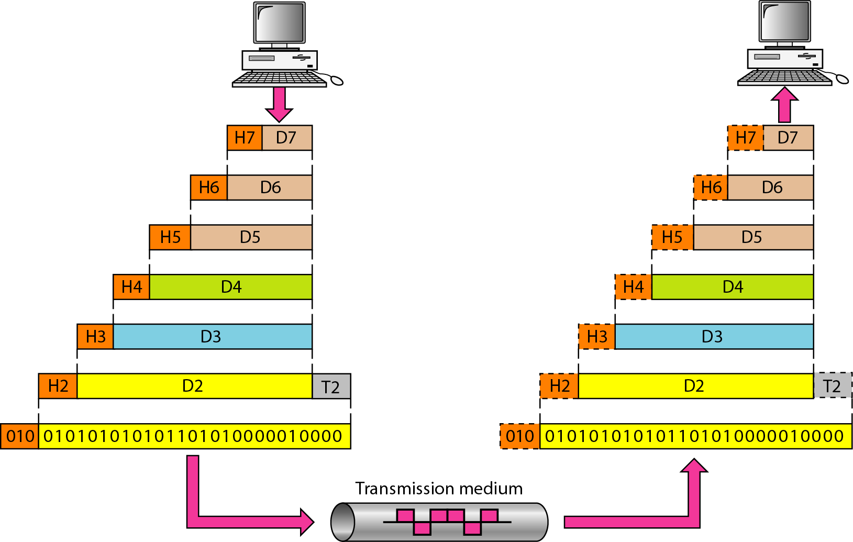

Seven layers of the OSI model:

1. Physical

-Responsible for movements of individual bits from one hop(node) to the next.

-Concerned with physical characteristics of interface and media, representation of bits, data rate, synchronization of bits, line configuration, physical topology, transmission mode.

-To transmit bits over a medium; to provide mechanical and electrical specifications.

2. Data Link

-Responsible for moving frames from one hop(node) to the next.

-Concerned with framing, physical addressing, flow control, error control, access control.

-To organize bits into frames; to provide hop-to-hop delivery.

3. Network

-Responsible for the delivery of individual packets from the source host to the destination host.

-Concerned with logical addressing and routing.

-To move packets from source to destination; to provide internetworking.

4. Transport

-Responsible for the delivery of a message from one process to another.

-Concerned with service-point addressing, segmentation and reassembly, connection control, flow control, and error control.

-To provide reliable process-to-process message delivery and error recovery.

5. Session

-Responsible for dialog control and synchronization.

-Concerned with dialog control and synchronization.

-To establish, manage and terminate sessions.

6. Presentation

-Responsible for translation, compression, and encryption.

-Concerned with translation, encryption, and compression.

-To translate, encrypt, and compress data.

7. Application

-Responsible for providing services to the user.

-Concerned with network virtual terminal, file transfer/access/management (FTAM), mail services, and directory services.

-To allow access to network resources.

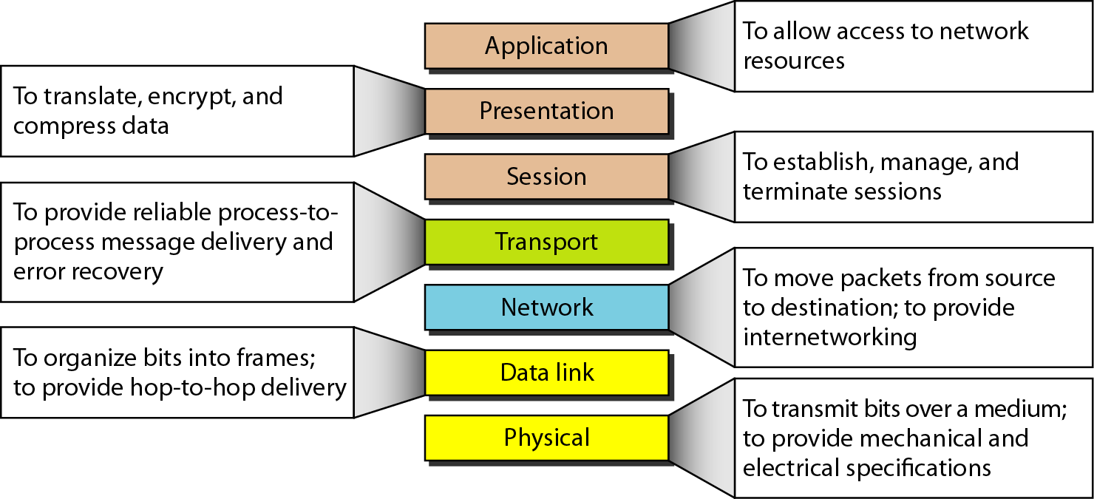

TCP/IP Protocol Suite:

-The original TCP/IP protocol suite was defined as having four layers:

Host-to-host network, Internet, Transport, and application.

-When comparing to OSI, we say that TCP/IP has five layers:

Physical, data link, network, transport, and application.

-Four levels of addresses are used in internet employing the TCP/IP protocols:

Physical, logical, port, and specific.

-Most local-area networks use a 48-bit (6-byte) physical address written as 12 hexadecimal digits. Every bit (2 hexadecimal digits) is separated by a colon:

Ex. A 6-byte (12 hex digit) physical address --> 07:01:02:01:2C:4B

-The physical addresses will change from hop to hop but the logical addresses usually remain the same.

-A port address is a 16-bit address represented by one decimal number: Ex. 753

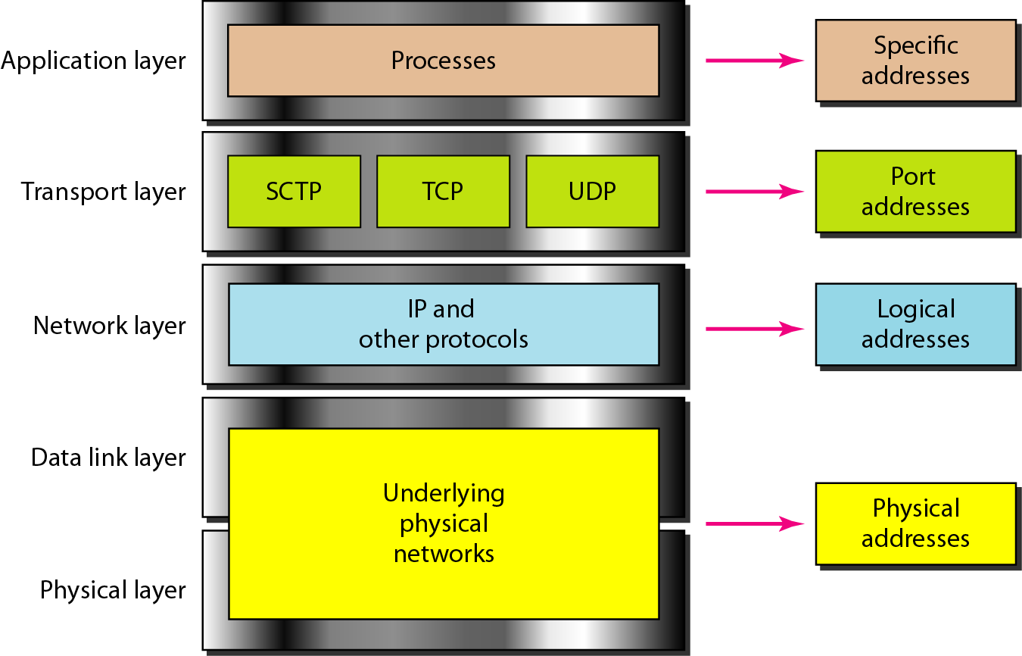

**Chapter 8:**

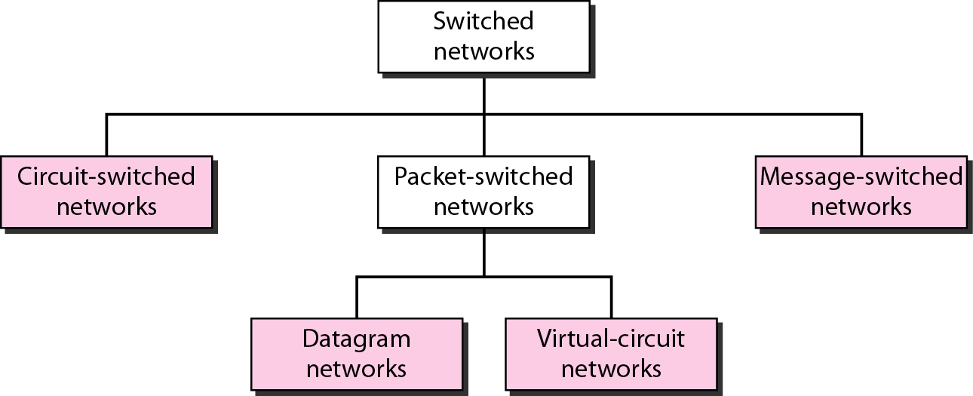

Circuit-Switched Networks:

-A circuit-switched network consists of a set of switches connected by physical links. A connection between two stations is a dedicated path made of one or more links. However, each connection uses only one dedicated channel on each link. Each link is normally divided into n channels by using FDM or TDM.

-A circuit-switched network is made of a set of switches connected by physical links, in which each link is divided into n channels.

-In circuit switching, the resources need to be reserved during the setup phase; the resources remain dedicated for the entire duration of data transfer until the teardown phase.

-Switching at the physical layer in the traditional telephone network uses the circuit-switching approach.

Datagram Networks:

-In data communications, we need to send messages from one end system to another. If the message is going to pass through a packet-switched network, it needs to be divided into packets of fixed or variable size. The size of the packet is determined by the network and the governing protocol.

-In a packet-switched network, there is no resource reservation; resources are allocated on demand.

-A switch in a datagram network uses a routing table that is based on the destination address.

-The destination address in the header of a packet in a datagram network remains the same during the entire journey of the packet.

-Switching in the Internet is done using the datagram approach to packet switching at the network layer.

Virtual Networks:

-A virtual-circuit network is a cross between a circuit-switched network and a datagram network. It has some characteristics of both.

-In virtual-circuit switching, all packets belonging to the same source and destination travel the same path; but the packets may arrive at the destination with different delays if resource allocation is on demand.

-Switching at the data link layer in a switched WAN is normally implemented by using virtual- circuit techniques.

- Types of delay in circuit-switched networks (4 Ways)

- Types of multiplexing (3 Types)

-Time Division Multiplexing

-Frequency Division Multiplexing

-Wave-Length Division Multiplexing (Used only for fibre-optics)

-Connectionless/Datagram

-Connection Oriented - Relationship between packets / Contrast with Datagram packets

**Switches:**

-We use switches in circuit-switched and packet-switched networks.

According to the Clos criterion:

*n* = (N/2)1/2

*k* > 2*n* – 1

Crosspoints ≥ 4N [(2N)1/2 – 1]